**Table Of Contents**

ABSTRACT 2

INTRODUCTION 3

ABOUT THE PROJECT 8

CLASSIFICATION CHATBOT FOR SIMPLE QUESTIONS PROJECT SURVEY 9

SYSTEM ANALYSIS 11

DESIGN 16

IMPLEMENTATION 19

TESTING 24

OUTPUT SCREENS 28

CONCLUSION 30

BIBLIOGRAPHY 31

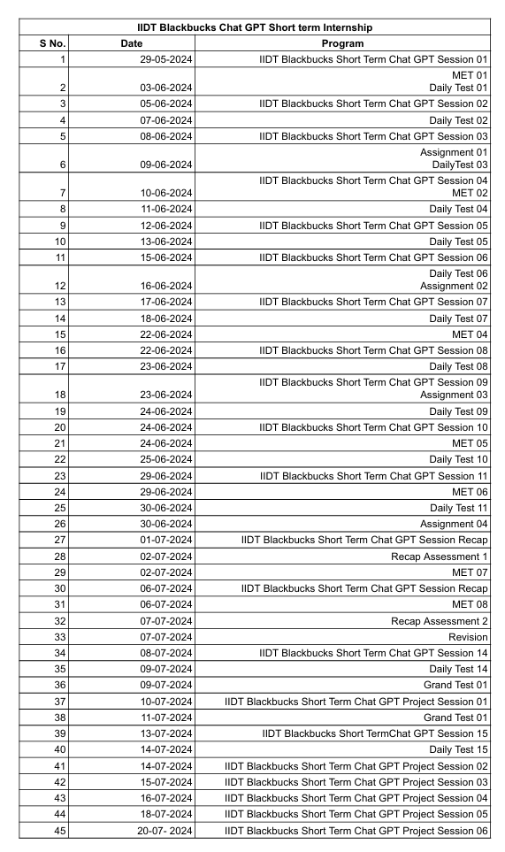

# 

# **ABSTRACT**

This project is about *Chatbot for Simple Questions.*

**Purpose and Goals**

The primary objective of this project is to develop an advanced chatbot using Gemini AI, leveraging its natural language understanding and response generation capabilities. The chatbot aims to provide users with a highly interactive and personalized conversational experience. By harnessing Gemini AI's innovative language processing, the goal is to explore new AI-driven interactions, offering users a seamless and intuitive platform.

**Methods or Technologies Used**

The development involves integrating Gemini AI's API, known for its advanced natural language processing. This process includes creating a streamlined interface for smooth user interaction. The project employs cutting-edge machine learning methodologies to enhance Gemini AI's capabilities, ensuring robust performance across various scenarios. Emphasis is on designing an accessible and user-friendly interface for diverse user needs.

**Key Features or Functionalities**

The chatbot showcases several features highlighting its versatility:

* **Dynamic response generation**: Powered by Gemini AI, it generates real-time responses, ensuring prompt and relevant feedback.
* **Contextual awareness**: Maintains context throughout conversations, delivering coherent responses.
* **Adaptive conversational abilities**: Adjusts responses based on user inputs and interaction patterns.
* **Intuitive design**: Prioritizes simplicity and accessibility, catering to users with varying technical proficiency.

**Results or Impact**

Initial testing shows the chatbot meets its objectives, handling diverse inquiries with accuracy. Users experience fluid and engaging interactions, facilitated by Gemini AI's advanced language capabilities. The chatbot's intuitive design and adaptive features enhance user engagement and satisfaction across multiple domains.

**Conclusions or Future Work**

This project demonstrates the transformative potential of Gemini AI in creating sophisticated chatbot solutions. Future work will focus on refining functionalities, enhancing response accuracy, and exploring applications in healthcare, education, and customer service. Continuous innovation will drive the evolution of AI-driven conversational interfaces, making them essential tools for modern interactions.

# **Introduction**

**What is Generative AI?**

Generative AI, a subset of artificial intelligence, has emerged as a groundbreaking technology capable of creating new content and data. Unlike traditional AI systems that primarily analyze and classify existing data, generative AI models can generate entirely novel outputs, such as text, images, music, and even code. This revolutionary capability has opened up vast possibilities across various industries and applications.

**How Generative AI Works:**

At the core of generative AI are complex algorithms, often based on neural networks, trained on massive datasets.

These models learn to identify patterns and underlying structures within the data, enabling them to generate new content that shares similar characteristics. The process typically involves two key steps:

1. **Training:** The model is fed a large amount of data, allowing it to learn the patterns and relationships within the information.
2. **Generation:** Once trained, the model can generate new content by sampling from the learned distribution.

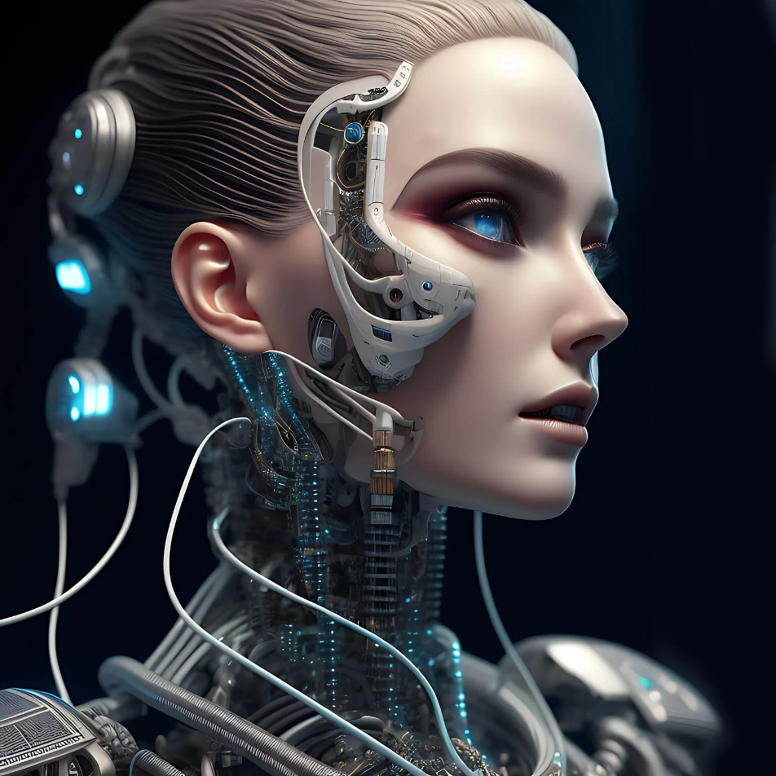

**Key Techniques in Generative AI:**

Several techniques have been instrumental in the advancement of generative AI:

* **Generative Adversarial Networks (GANs):**

GANs consist of two neural networks, a generator and a discriminator, competing against each other. The generator creates new data, while the discriminator evaluates its authenticity. This adversarial process leads to the generation of increasingly realistic outputs.

* **Variational Autoencoders (VAEs):**

VAEs encode input data into a lower-dimensional latent space and then decode it to reconstruct the original data. By manipulating the latent space, new data can be generated.

* **Transformer Models:**

These models have gained prominence in natural language processing and have been adapted for generative tasks. They excel at capturing long-range dependencies in data, enabling the generation of coherent and contextually relevant text.

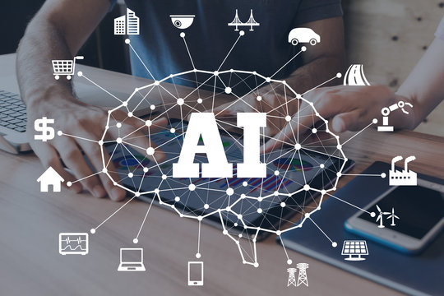

**Applications of Generative AI:**

1. **Natural Language Processing:**
   * Generative AI models like GPT-4 are used in chatbots, virtual assistants, and content generation, providing coherent and contextually relevant responses.
   * AI can assist in writing articles, creating marketing content, and generating reports. This helps automate repetitive tasks and allows humans to focus on more creative aspects.
2. **Image and Video Synthesis:**
   * AI can create realistic images and videos, which are used in entertainment, marketing, and even healthcare for creating medical imaging.
   * In medical imaging, AI-generated data can help train diagnostic models, create detailed simulations, and assist in planning complex surgeries.
3. **Music and Audio Generation:**
   * AI can compose original music pieces, generate accompaniments, and even create new genres. Musicians and composers use these tools to explore new creative possibilities and enhance their work.
   * Generative models can produce realistic synthetic voices for use in audiobooks, virtual assistants, and accessibility tools.
4. **Simulation and Modelling:**
   * The AI-generated simulations are used in various scientific fields, such as climate modelling, molecular simulations, and physics experiments. These models help researchers explore complex phenomena and predict future outcomes.
   * Generative AI can create synthetic data to augment training datasets for machine learning models, improving their performance and robustness.

**Ethical Considerations and Challenges:**

While generative AI holds immense potential, it also raises several ethical considerations and challenges that must be addressed to ensure its responsible use.

1. **Misinformation and Deepfakes:**
   * + **Risks**: The ability of generative AI to create highly realistic images, videos, and text raises concerns about the spread of misinformation and the creation of deepfakes. These false media can be used maliciously to deceive people, manipulate public opinion, and harm reputations.
     + **Mitigation**: Developing robust detection methods, promoting digital literacy, and establishing ethical guidelines are crucial steps in mitigating these risks.
2. **Bias and Fairness**:
   * + **Challenges**: Generative AI models learn from large datasets that may contain biases. These biases can be reflected in the generated content, perpetuating stereotypes and unfair practices.
     + **Solutions**: Ensuring diverse and representative training data, implementing bias detection mechanisms, and continuously monitoring AI outputs can help address these challenges.
3. **Privacy Concerns**:
   * + **Data Usage**: The use of large datasets for training generative models can raise privacy concerns, especially if sensitive or personal information is included.
     + **Regulations**: Adhering to data protection regulations, anonymizing data, and obtaining explicit consent from data owners are essential practices to protect privacy.

**Future Directions and Research:**

The field of generative AI is rapidly evolving, with ongoing research aimed at enhancing model capabilities, addressing ethical concerns, and exploring new applications.

* 1. **Improved Model Architectures**:
     + - * **Hybrid Models**: Combining different generative techniques, such as GANs and VAEs, can leverage their strengths and improve the quality of generated content.
         * **Scalability**: Developing scalable models that can handle increasingly large and complex datasets will enhance the performance and applicability of generative AI.
  2. **Ethical AI Development**:
     + - * **Transparent AI**: Promoting transparency in AI development, including explainable models and open-access research, can build trust and accountability in generative AI applications.
         * **Inclusive AI**: Ensuring that AI benefits a diverse range of users and communities, addressing biases, and promoting fair practices are key goals for future development.
  3. **Novel Applications**:
     + - * **Interdisciplinary Research**: Collaborating with experts from various fields, such as healthcare, education, and the arts, can uncover new and impactful uses for generative AI.
         * **AI in Creativity**: Exploring the role of AI as a creative partner, rather than just a tool, can lead to innovative artistic expressions and new forms of collaboration between humans and machines.

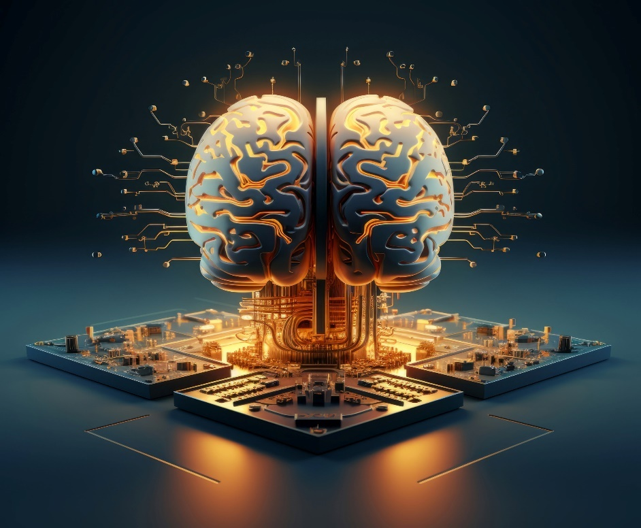

**Conclusion:**

Generative AI has significantly advanced the capabilities of artificial intelligence, offering innovative solutions across various fields, from natural language processing to creative arts and scientific research. The development of sophisticated models such as GANs, VAEs, and Transformers has enabled AI to generate highly realistic and useful content, revolutionizing the way we interact with technology. These advancements have not only enhanced the efficiency and creativity of numerous applications but also opened up new possibilities for automation and human-machine collaboration. The profound impact of generative AI is evident in its ability to streamline processes, produce high-quality outputs, and provide personalized experiences, thereby driving progress and innovation in numerous industries.



However, the rise of generative AI also brings forth significant ethical considerations and challenges. Issues related to misinformation, bias, privacy, and the responsible use of AI-generated content need to be carefully addressed to ensure the technology's positive impact on society. As we continue to explore the potential of generative AI, it is crucial to establish ethical guidelines, promote transparency, and develop robust mechanisms to mitigate associated risks. The future of generative AI lies in striking a balance between leveraging its transformative capabilities and upholding ethical standards, ensuring that it remains a force for good in advancing human knowledge, creativity, and well-being.

# **ABOUT THE PROJECT**

**Project Definition:**

The Pizza Chatbot is an AI-powered application designed to assist users in ordering pizza seamlessly through a conversational interface. It interacts with users in natural language, helping them to select pizza types, customize their orders, and complete transactions efficiently. The chatbot aims to enhance user experience by providing a user-friendly, interactive platform for ordering pizza and addressing customer queries.

**Proposed Solution:**

The proposed solution involves developing a chatbot that leverages natural language processing (NLP) to understand and respond to user inputs related to pizza ordering. The chatbot will:

* **Understand User Queries**: Interpret various user inputs and provide relevant responses.
* **Guide Through Ordering Process**: Assist users in selecting pizza sizes, toppings, and additional items.
* **Process Transactions**: Facilitate order placement and payment through integration with payment gateways.
* **Provide Order Status**: Update users on the status of their orders and estimated delivery times.
* **Handle Customer Support**: Address common customer queries and issues regarding orders and services.

**Objective:**

* **User Interaction**: Develop an intuitive and engaging chatbot interface that simplifies the pizza ordering process.
* **Order Customization**: Allow users to customize their orders with various options such as size, toppings, and special instructions.
* **Transaction Management**: Implement secure payment processing and order confirmation features.
* **Customer Support**: Provide timely and accurate responses to customer queries related to orders, delivery, and other services.
* **Scalability**: Ensure that the chatbot can handle multiple concurrent users and integrate with various platforms (e.g., web, mobile).
* **Data Analytics**: Collect and analyse user interaction data to improve the chatbot's performance and user satisfaction.

# **Chatbot for Simple Questions Project Survey**

**Theoretical Background:**

The Generative AI Pizza Chatbot project is based on principles of artificial intelligence, natural language processing (NLP), and conversational agents. Generative AI involves models that can generate text, provide responses, and simulate human-like conversations based on input data. In this project, the chatbot leverages advanced NLP techniques to interact with users in a natural, conversational manner. The model is designed to understand user queries about pizza orders, provide recommendations, and handle transactional tasks.

**Existing System with Drawbacks:**

Current pizza ordering systems often rely on rule-based or template-driven chatbots that follow predefined scripts and decision trees. These systems have several limitations:

**Drawbacks of Existing Systems:**

1. **Limited Flexibility:** Rule-based systems can only handle scenarios predefined by the developers, leading to limited interaction capabilities.
2. **Lack of Personalization:** These systems often fail to provide personalized experiences based on user preferences or past interactions.
3. **Inability to Handle Complex Queries:** Rule-based chatbots may struggle with complex or unexpected queries, resulting in less effective user interactions.
4. **Scalability Issues:** Expanding the system to handle new types of interactions or additional features can be cumbersome and time-consuming.

**Proposed System with Features:**

The proposed Generative AI Pizza Chatbot addresses the drawbacks of existing systems by utilizing advanced generative models to provide a more dynamic and engaging user experience.

**Features of the Proposed System:**

1. **Dynamic Interaction:** The chatbot uses generative AI to understand and respond to a wide range of user inputs in natural language, allowing for more flexible and engaging conversations.
2. **Personalized Recommendations:** By analysing user preferences and interaction history, the chatbot can offer personalized pizza recommendations and promotions.
3. **Contextual Understanding:** The generative model can maintain context across multiple interactions, providing coherent and relevant responses even in extended conversations.
4. **Order Management:** Users can place and customize pizza orders directly through the chatbot, with real-time updates on order status and delivery estimates.
5. **Adaptive Learning:** The system can continuously improve its responses and interactions based on user feedback and new data, enhancing overall performance and user satisfaction.

**Advantages of the Proposed System:**

**1. Enhanced User Experience**

The Generative AI Pizza Chatbot offers a significantly improved user experience compared to traditional systems. Unlike rule-based or template-based chatbots, which often provide rigid and predictable responses, the generative model delivers dynamic and engaging interactions. By leveraging advanced natural language processing techniques, the chatbot can understand and respond to a wide range of user inputs in a natural, conversational manner. This capability makes interactions feel more intuitive and human-like, enhancing overall user satisfaction and engagement.

**2. Increased Personalization**

One of the major strengths of the Generative AI Pizza Chatbot is its ability to provide highly personalized recommendations and interactions. By analysing user preferences, past interactions, and behavioural data, the chatbot can tailor its responses to individual users. For instance, it can remember a user’s favourite pizza toppings or suggest special offers based on previous orders. This level of personalization not only improves the relevance of recommendations but also fosters a stronger connection between the user and the service, potentially leading to increased customer loyalty.

**3. Contextual Understanding and Adaptability**

The generative model employed in the chatbot excels in maintaining context across multiple interactions. This means that the chatbot can handle extended conversations without losing track of previous exchanges. For example, if a user initially inquiries about pizza options and later asks about delivery times, the chatbot can seamlessly integrate these pieces of information to provide coherent and contextually relevant responses. This adaptability ensures a smoother and more natural conversational flow, enhancing the overall user experience.

**4. Improved Accuracy and Relevance**

Generative AI models are adept at understanding nuanced user queries and generating accurate responses. Unlike simpler systems that may struggle with ambiguous or complex questions, the Generative AI Pizza Chatbot can analyse the context and intent behind user inputs to deliver more precise and relevant information. This accuracy reduces the likelihood of misunderstandings and ensures that users receive the information or assistance they need, thereby improving the efficiency of the ordering process.

**5. Scalability and Flexibility**

The proposed system is designed with scalability and flexibility in mind. Generative AI models can easily handle a large volume of interactions simultaneously, making them suitable for high-traffic environments. Additionally, the chatbot can be updated and adapted with new data, features, or improvements without requiring extensive reprogramming. This scalability and flexibility allow the system to grow and evolve with changing user needs and preferences, ensuring long-term viability and effectiveness.

# **SYSTEM ANALYSIS**

System analysis involves studying the components of a system to understand its objectives, performance, and how to improve its functionality. For the Generative AI Pizza Chatbot, this analysis will focus on the functional and non-functional requirements, software and hardware specifications, and module descriptions relevant to its development.

**Specification:**

**Functional Requirements:**

The following functional requirements outline the core functionalities that the Generative AI Pizza Chatbot must deliver:

1. **User Interaction**: The chatbot must be able to interact with users in natural language, understanding and responding to a wide range of pizza-related queries.
2. **Order Management**: Users should be able to place, customize, and track pizza orders through the chatbot interface.
3. **Personalized Recommendations**: The chatbot must offer pizza recommendations based on user preferences and past interactions.
4. **Transaction Handling**: Integration with payment gateways to process transactions securely.
5. **Order Status Updates**: Provide real-time updates on order status and estimated delivery times.
6. **Customer Support**: Address user inquiries and issues related to orders and pizza offerings.

**Non-Functional Requirements:**

The non-functional requirements ensure the system's quality and performance:

1. **Maintainability**: The system should be designed for easy updates and maintenance, allowing for the addition of new features and adjustments based on user feedback.
2. **Robustness**: The chatbot must be resilient to various inputs and potential errors, ensuring stable performance under different conditions.
3. **Reliability**: The system should consistently perform its functions accurately and dependably, without frequent downtimes or failures.
4. **Scalability**: The chatbot must handle an increasing number of users and interactions efficiently, scaling as needed without performance degradation.
5. **Speed**: The system should deliver prompt responses to user queries and process orders quickly, ensuring a smooth user experience.

**Software Requirements**

Selecting the appropriate software tools is crucial for the development of the Generative AI Pizza Chatbot:

|  |  |
| --- | --- |
| **Programming Language** | **Python** |
| **Technology** | **Jupyter Notebook** |
| **Operating System** | **Windows 11** |
| **Browser** | **Google Chrome** |
| **NLP Frameworks** | **Dialog flow, Rasa** |

**Hardware Requirements**

The hardware selection ensures the system runs smoothly during development and deployment:

|  |  |
| --- | --- |
| **Processor** | **Intel Core i5 or higher** |
| **RAM Capacity** | **8GB or higher** |
| **Hardisk** | **512 GB SSD** |
| **I/O Devices** | **Keyboard, Mouse, Monitor** |

**Module Description**

For predicting the literacy rate of India, our project has been divided into following modules:

1. Data Collection & Pre-processing
2. Model Development & Training
3. Integration & Testing
4. Deployment & Monitoring

**1.** **Data Collection & Pre-processing**

To gather and prepare data necessary for training the chatbot and ensuring its effectiveness in understanding and responding to user queries.

* **Data Collection**:
  + **Sources**: Collect data from various sources including pizza menus, customer reviews, order histories, and interaction logs.
  + **Types of Data**: Include details such as pizza types, ingredients, user preferences, order history, and common customer queries.
  + **Tools**: Use web scraping tools, APIs, and data entry methods to compile comprehensive datasets.
* **Data Pre-processing**:
  + **Cleaning**: Address issues like missing values, duplicate entries, and inconsistencies. Ensure the data is accurate and reliable.
  + **Normalization**: Standardize data formats to make the data uniform and comparable. This may involve scaling numerical values or converting text to lowercase.
  + **Encoding**: Convert categorical data (e.g., pizza types, toppings) into a format suitable for machine learning models, such as one-hot encoding or label encoding.
  + **Segmentation**: Divide data into training, validation, and testing sets to evaluate the model’s performance effectively.

**2. Model Development & Training**

To develop and train a generative AI model capable of understanding user inputs and generating appropriate responses related to pizza orders.

* **Model Selection**:
  + **Generative Models**: Evaluate and select suitable models for natural language generation (NLG) such as GPT (Generative Pre-trained Transformer), BERT (Bidirectional Encoder Representations from Transformers), or other advanced language models.
  + **NLP Techniques**: Incorporate techniques such as sequence-to-sequence models, attention mechanisms, and reinforcement learning to improve conversational abilities.
* **Training**:
  + **Feature Engineering**: Extract relevant features from the pre-processed data to train the model. This may include user preferences, order patterns, and conversational context.
  + **Training Process**: Use frameworks like TensorFlow or PyTorch to train the model. Configure hyperparameters, such as learning rate and batch size, to optimize performance.
  + **Validation**: Evaluate the model’s performance on validation data to ensure it generalizes well and does not overfit to the training data.
  + **Fine-Tuning**: Adjust the model based on validation results and user feedback to improve its accuracy and relevance.

1. **Integration & Testing**

To integrate the trained model with the chatbot interface and rigorously test its functionality to ensure it meets user needs effectively.

* **Integration**:
  + **Interface Development**: Build a user-friendly interface for the chatbot using web or mobile development platforms. Integrate the model with this interface to handle user interactions.
  + **APIs and Webhooks**: Set up APIs for communication between the chatbot and other services, such as payment gateways or order management systems.
* **Testing**:
* **Functionality Testing**: Verify that the chatbot performs all required functions, including handling user queries, placing orders, and providing recommendations.

**4. Deployment & Monitoring**

To deploy the chatbot to production environments and continuously monitor its performance to ensure it operates effectively and meets user expectations.

* **Deployment**:
  + **Environment Setup**: Deploy the chatbot on chosen platforms, such as a website or mobile app. Ensure compatibility with different devices and browsers.
  + **Configuration**: Configure server settings, load balancing, and security measures to ensure smooth and secure operation.
* **Monitoring**:
  + **Performance Tracking**: Monitor key performance indicators (KPIs) such as response time, accuracy, and user satisfaction. Use analytics tools to track these metrics.
  + **Error Handling**: Implement mechanisms to detect and handle errors or issues that arise during chatbot interactions. Provide a fallback mechanism or human support when necessary.

# **DESIGN**

**Block Diagram**

The block diagram is typically used for a higher level, less detailed description aimed more at understanding the overall concepts and less at understanding the details of implementation.

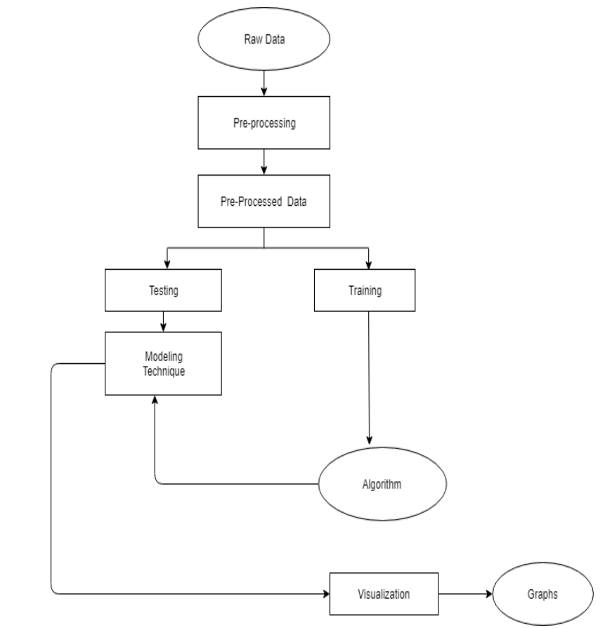

**Data Flow Diagrams:**

Data flow diagram (DFD) is a graphical representation of “flow” of data through an information system, modelling its process concepts. Often they are a preliminary step used to create an overview of the system which can later be elaborated. DFD’s can also be used for the visualization of data processing (structured design).

A DFD shows what kinds of information will be input to and output from the system, where the data will come from and go to, and where the data will be stored. It doesn’t show information about timing of processes, or information about whether processes will operate in sequence or parallel. A DFD is also called as “bubble chart”.

**DFD Symbols:**

In the DFD, there are four symbols:

* A square define a source or destination of system data.
* An arrow indicates dataflow. It is the pipeline through which the information flows.
* A circle or a bubble represents transforms dataflow into outgoing dataflow.
* An open rectangle is a store, data at reset or at temporary repository of data.

**Dataflow:** Data move in a specific direction from an origin to a destination.

**Process:** People, procedures or devices that use or produce (Transform) data. The physical component is not identified.

**Sources:** External sources or destination of data, which may be programs, organizations or other entity.

**Data store:** Here data is stored or referenced by a process in the system’s #

In our project, we had built the data flow diagrams at the very beginning of business process modelling in order to model the functions that our project has to carry out and the interaction between those functions together with focusing on data exchanges between processes.

**Context level DFD:**

A Context level Data flow diagram created using select structured systems analysis and design method (SSADM). This level shows the overall context of the system and its operating environment and shows the whole system as just one process. It does not usually show data stores, unless they are “owned” by external systems, e.g. are accessed by but not maintained by this system, however, these are often shown as external entities**.**

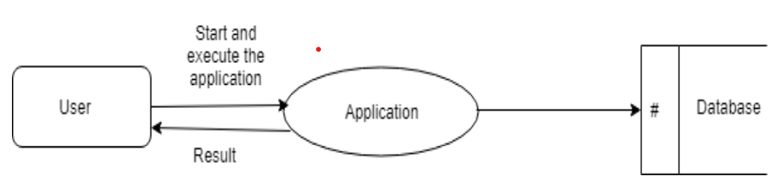

**Top level DFD:**

A data flow diagram is that which can be used to indicate the clear progress of a business venture. In the process of coming up with a data flow diagram, the level one provides an overview of the major functional areas of the undertaking. After presenting the values for most important fields of discussion, it gives room for level two to be drawn.

# **IMPLEMENTATION**

Implementation is the stage where theoretical designs and models are translated into a functioning system. For the Generative AI Pizza Chatbot project, this process involves several key phases, including planning, development, testing, and deployment. This section provides a comprehensive overview of the steps involved, the technologies used, and the considerations for a successful implementation.

**1. Implementation Overview**

**1.1. Planning and Preparation** The implementation phase begins with careful planning to ensure that the project meets its objectives. This includes:

* **Requirement Validation:** Reconfirming the project requirements and ensuring alignment with the initial design and user expectations.
* **Resource Allocation:** Identifying and allocating the necessary resources, including hardware, software, and personnel.
* **Development Environment Setup:** Installing and configuring development tools, libraries, and frameworks.

**1.2. System Setup** This involves setting up the infrastructure required for deploying and running the chatbot:

* **Web Server Deployment:** Deploy the application on a web server or cloud platform. Options include AWS, Heroku, or Google Cloud. The choice of platform will depend on factors such as scalability, cost, and ease of use.
* **Access Management:** Implement mechanisms to handle simultaneous access from multiple clients, ensuring that the system can handle concurrent interactions effectively.

**2. Technologies and Tools**

**2.1. Python**

Python serves as the core programming language for this project due to its simplicity, readability, and extensive libraries. Key features include:

* **High-Level Language:** Python’s syntax is designed to be easy to read and write, making development faster and more intuitive.
* **Dynamic Typing:** Python’s dynamic type system allows for greater flexibility in coding and reduces the likelihood of type-related errors.
* **Extensive Libraries:** Python’s large standard library and ecosystem support a wide range of functionalities required for the chatbot.

**2.2. Libraries and Frameworks**

**2.2.1. Pandas**

* **Purpose:** Used for data manipulation and preprocessing.
* **Features:**
  + **Data Frame:** Allows for efficient handling of structured data.
  + **Data Cleaning:** Facilitates handling missing data, merging datasets, and reshaping data structures.
  + **Transformation:** Supports operations such as filtering, sorting, and aggregating data.

**2.2.2. NumPy**

* **Purpose:** Provides support for numerical computations and array operations.
* **Features:**
  + **Multidimensional Arrays:** Efficient handling of large datasets and mathematical operations.
  + **Mathematical Functions:** Includes functions for linear algebra, statistics, and numerical integration.

**2.2.3. Scikit-learn**

* **Purpose:** Implements machine learning algorithms and tools for model evaluation.
* **Features:**
  + **Classification Algorithms:** Includes Logistic Regression, decision trees, and random forests.
  + **Preprocessing Tools:** Provides functions for scaling, normalizing, and splitting data.
  + **Model Evaluation:** Tools for accuracy assessment, cross-validation, and hyperparameter tuning.

**2.2.4. Matplotlib & Seaborn**

* **Purpose:** For data visualization.
* **Features:**
  + **Matplotlib:** Enables creation of a wide range of static, interactive, and animated plots.
  + **Seaborn:** Simplifies complex statistical visualizations, offering built-in themes and colour palettes.

**2.2.5. Flask/Django**

* **Purpose:** Web frameworks for building and deploying the chatbot interface.
* **Features:**
  + **Flask:** Lightweight framework for quick development and easy integration.
  + **Django:** Full-featured framework for larger applications, providing built-in tools for database management and user authentication.

**3. Implementation Steps**

**3.1. User Interface (UI) Development**

**3.1.1. Design and Prototyping**

* **Wireframes and Mock-ups:** Develop wireframes and design mock-ups to visualize the user interface and interactions.
* **User Experience (UX):** Ensure the interface is intuitive and user-friendly, with clear navigation and interaction elements.

**3.1.2. Development**

* **Frontend Development:** Use HTML, CSS, and JavaScript to build the frontend of the chatbot application.
* **Integration with Backend:** Connect the frontend to the backend using APIs, ensuring that user inputs are correctly handled and processed.

**3.2. Chatbot Engine Development**

**3.2.1. Model Training**

* **Data Collection:** Gather and preprocess data required for training the chatbot. This includes user queries and responses.
* **Feature Engineering:** Transform raw data into features suitable for model training.
* **Training:** Use Python libraries such as Scikit-learn to train the classification model. Logistic Regression is employed for binary classification tasks, such as identifying user intents.

**3.2.2. Model Integration**

* **Integration with Chatbot:** Connect the trained model with the chatbot engine to process and generate responses based on user inputs.
* **Testing:** Perform extensive testing to validate that the chatbot responses are accurate and relevant.

**3.3. Backend Development**

**3.3.1. Database Setup**

* **Database Design:** Design the schema to store user data, chat history, and other relevant information.
* **Implementation:** Use a relational database management system (RDBMS) like MySQL or PostgreSQL, or a NoSQL database like MongoDB, depending on the project needs.

**3.3.2. Backend Logic**

* **Session Management:** Implement logic to manage user sessions, ensuring that each interaction is tracked and managed properly.
* **Order Processing:** Develop functionality to handle pizza orders, including adding items to the cart, processing payments, and managing order status.

**3.4. External Services Integration**

**3.4.1. Payment Gateway**

* **Integration:** Connect with a payment gateway like Stripe or PayPal to handle transactions securely.
* **Testing:** Ensure that the payment process is smooth and error-free.

**3.4.2. Delivery System**

* **Integration:** Connect with delivery services or implement a delivery management system to handle order fulfilment and track delivery status.

**3.5. Testing and Quality Assurance**

**3.5.1. Unit Testing**

* **Component Testing:** Test individual components and modules to ensure they function correctly in isolation.

**3.5.2. Integration Testing**

* **End-to-End Testing:** Verify that different components work together seamlessly, from user input to chatbot response and order processing.

**3.5.3. User Acceptance Testing (UAT)**

* **Feedback Collection:** Conduct testing with real users to gather feedback and identify areas for improvement.
* **Iterative Improvements:** Adjust based on user feedback to enhance the system's performance and usability.

**3.6. Deployment**

**3.6.1. Deployment Strategy**

* **Environment Setup:** Configure the production environment, ensuring that all dependencies and configurations are correctly set up.
* **Deployment Tools:** Use deployment tools like Docker or CI/CD pipelines to streamline the deployment process.

**3.6.2. Monitoring and Maintenance**

* **Monitoring:** Implement monitoring tools to track system performance, user interactions, and potential issues.
* **Maintenance:** Regularly update the system to fix bugs, improve performance, and incorporate new features.

**3.7. Documentation**

**3.7.1. Code Documentation**

* **Inline Comments:** Provide detailed comments and explanations within the codebase to facilitate understanding and maintenance.
* **API Documentation:** Document APIs and endpoints for integration and usage.

**3.7.2. User Documentation**

* **User Guides:** Create comprehensive user guides and FAQs to assist users in interacting with the chatbot.
* **Help Resources:** Provide support resources for troubleshooting and assistance.

**3.8. Training and Support**

**3.8.1. Training**

* **Administrator Training:** Train administrators and support staff on how to manage and operate the chatbot system.
* **User Training:** Offer training sessions or resources for end-users to effectively interact with the chatbot.

**3.8.2. Support**

* **Support Channels:** Establish support channels such as email or chat for users to report issues and seek assistance.
* **Continuous Improvement:** Regularly review feedback and make improvements to enhance the chatbot’s functionality and user experience.

# **TESTING**

Testing is an essential phase in the development lifecycle of the Generative AI Pizza Chatbot project. It ensures that the chatbot system functions as intended and meets the requirements and expectations of users. This phase involves executing the chatbot under various conditions to identify and resolve potential issues, ensuring the system's reliability, performance, and user satisfaction.

**Black Box Testing**

**Black Box Testing** focuses on evaluating the functionality of the chatbot based on its requirements and specifications, without knowledge of its internal code or structure. This testing method ensures that the chatbot performs its intended functions correctly and handles various user inputs as expected.

**Techniques in Black Box Testing:**

1. **Decision Table Testing:** Decision Table Testing is used to validate different functional scenarios of the chatbot by creating a table that maps possible inputs to expected outputs. For example, a decision table for the pizza chatbot might include scenarios such as ordering a pizza with different toppings, selecting various sizes, and handling special requests. This method helps ensure that the chatbot correctly processes all possible input combinations and generates the appropriate responses. It is particularly useful for testing complex functionalities with multiple conditions.
2. **All Pairs Testing:** All Pairs Testing, also known as Pairwise Testing, involves testing all possible pairs of input conditions to identify defects that may arise due to interactions between different conditions. For the chatbot, this means testing various combinations of user inputs, such as different pizza sizes and toppings, to ensure that the chatbot handles all possible input pairs effectively. This technique helps identify potential issues that may not be apparent when testing individual conditions in isolation.
3. **State Transition Testing:** State Transition Testing examines how the chatbot transitions between different states based on user interactions. For instance, the chatbot might transition from a "greeting" state to an "ordering" state when a user expresses interest in placing an order. This method ensures that the chatbot maintains the correct conversational flow and handles state changes appropriately. It helps verify that the chatbot responds correctly to various user inputs and transitions smoothly between different stages of interaction.
4. **Equivalence Partitioning:** Equivalence Partitioning involves dividing the input data into different classes or partitions and testing representative values from each class. For the pizza chatbot, this could involve testing various categories of pizza toppings, sizes, and delivery options to ensure that the chatbot handles different types of inputs consistently. This technique helps reduce the number of test cases by focusing on representative samples from each partition, making it easier to identify defects and ensure comprehensive coverage.

**Validation and Verification:**

* **Validation:** Validation ensures that the chatbot meets user expectations and performs its intended functions effectively. It involves testing whether the chatbot delivers accurate and relevant responses based on user inputs and requirements. For example, validation tests might include verifying that the chatbot correctly processes pizza orders, provides accurate delivery information, and handles user queries appropriately.
* **Verification:** Verification confirms that the chatbot adheres to its design specifications and functions as intended. This includes testing the chatbot's adherence to functional requirements, ensuring that all implemented features work correctly, and verifying that the system behaves as expected under different conditions. Verification helps ensure that the chatbot's internal logic and processes are correctly implemented and that the system meets its design goals.

**White Box Testing**

**White Box Testing** requires knowledge of the chatbot's internal code and logic. It focuses on verifying the functionality of the code, algorithms, and data flows within the chatbot. This type of testing ensures that the chatbot's internal processes are correctly implemented and that the system functions as expected.

**Techniques in White Box Testing:**

1. **Unit Testing:** Unit Testing involves testing individual components or modules of the chatbot in isolation to ensure that they function correctly. For example, each function or method responsible for processing user inputs, generating responses, or managing conversation state can be tested separately. Automated testing tools such as pytest or unit test in Python can be used to streamline the unit testing process. Unit tests help identify defects at an early stage and ensure that each component performs its intended tasks correctly.
2. **Integration Testing:** Integration Testing involves combining and testing multiple components or modules of the chatbot to ensure that they work together seamlessly. For instance, testing the integration between the natural language processing (NLP) module and the response generation module verifies that inputs are correctly processed and appropriate responses are generated. Integration tests help identify issues that may arise from the interaction between different components and ensure that the system functions as a cohesive whole.
3. **System Testing:** System Testing evaluates the chatbot as a complete system to ensure that it meets all specified requirements and performs as expected. This includes testing the entire conversational flow, interaction with external APIs (e.g., for pizza delivery tracking), and overall system performance. End-to-end testing scenarios should be designed to cover various user interactions and use cases, ensuring that the chatbot delivers a seamless and satisfactory user experience.
4. **Regression Testing:** Regression Testing involves re-running previously successful tests to ensure that recent changes or updates have not introduced new defects. For the chatbot, this means testing existing functionalities after adding new features or making modifications to verify that the system remains stable and that no new issues have been introduced. Automated regression tests can help streamline this process and ensure that the chatbot continues to function correctly after updates.
5. **Acceptance Testing:** Acceptance Testing verifies that the chatbot meets customer requirements and is ready for deployment. This involves running test cases based on user stories or requirements and comparing the actual results with the expected results. For instance, testing whether the chatbot correctly handles pizza orders, customizations, and delivery inquiries as specified by the user requirements. User feedback during acceptance testing helps ensure that the chatbot aligns with user expectations and is ready for real-world use.

**Implementation of Testing in the Pizza Chatbot Project**

The testing phase of the Generative AI Pizza Chatbot project involves a systematic approach to ensure the system's quality and reliability. The following steps outline the implementation of testing for the chatbot:

1. **Test Planning:** Develop a comprehensive test plan that outlines the testing objectives, scope, resources, and schedule. Define test cases and scenarios based on the functional and non-functional requirements of the chatbot. The test plan should include details on the types of testing to be performed, the tools and techniques to be used, and the criteria for success.
2. **Test Design:** Design test cases and scripts for both black box and white box testing techniques. Create decision tables, state transition diagrams, and equivalence partitions for black box testing. Write unit tests, integration tests, and other white box tests based on the chatbot’s code and internal logic. Ensure that the test cases cover all relevant scenarios and use cases.
3. **Test Execution:** Execute the test cases according to the test plan. Perform black box testing to validate the functional aspects of the chatbot and white box testing to verify internal code and logic. Use automated testing tools and frameworks to streamline the testing process and ensure consistent execution of test cases.
4. **Defect Tracking and Reporting:** Track and document any defects or issues identified during testing. Report these defects to the development team for resolution. Ensure that defects are fixed and retested to verify that the issues have been addressed. Maintain a defect log to track the status of reported issues and their resolution.
5. **Test Evaluation and Review:** Evaluate the test results and review the effectiveness of the testing process. Assess whether the chatbot meets the required specifications and performs as expected. Conduct a final review to ensure that all testing objectives have been met and that the system is ready for deployment.
6. **User Acceptance Testing (UAT):** Involve end-users in the final testing phase to validate that the chatbot meets their expectations and requirements. Gather feedback from users and make any necessary adjustments based on their input. UAT helps ensure that the chatbot provides a satisfactory user experience and aligns with user needs.
7. **Deployment and Post-Deployment Testing:** Once testing is complete, deploy the chatbot to the production environment. Perform post-deployment testing to ensure that the system operates correctly in the live environment and continues to meet user needs. Monitor the chatbot's performance and address any issues that may arise after deployment.

# **OUTPUT SCREENS**

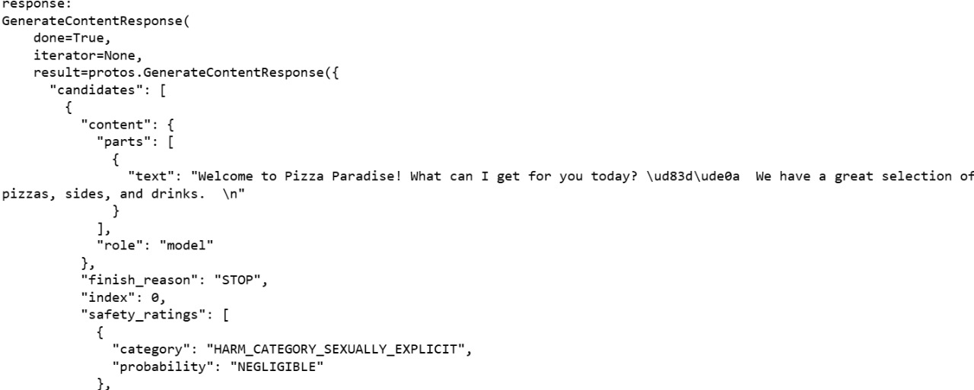

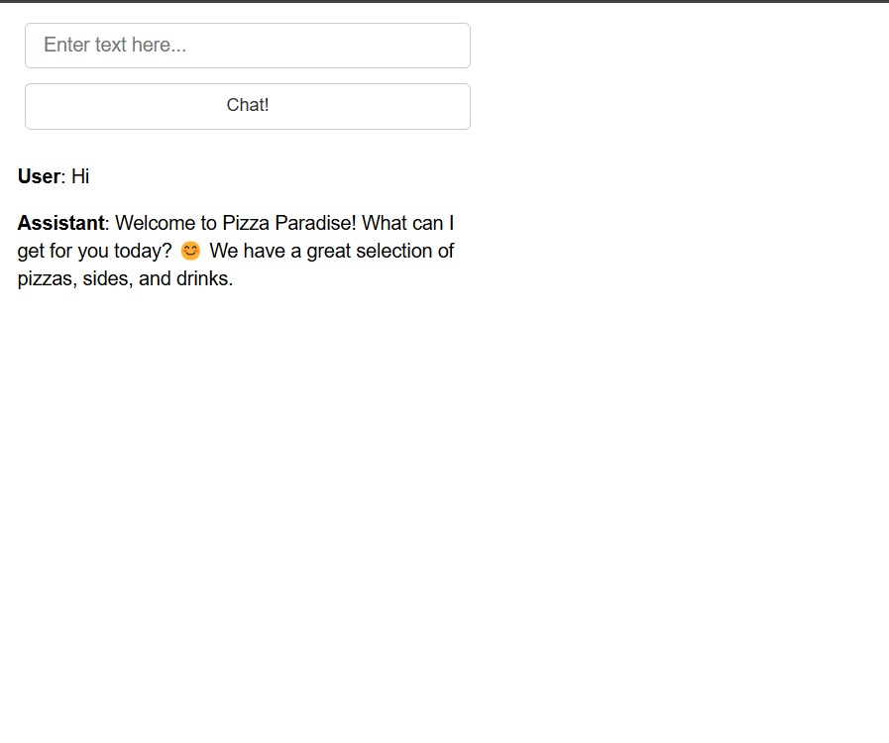

# **CONCLUSION**

The Generative AI Pizza Chatbot project exemplifies the successful application of advanced natural language processing and machine learning techniques to enhance the user experience in the pizza ordering domain. By integrating sophisticated AI algorithms with a user-friendly conversational interface, the project addresses key challenges in automated customer service, including providing personalized recommendations, handling diverse user queries, and streamlining the ordering process.

The chatbot’s design incorporates a variety of features, such as natural language understanding for accurately interpreting user inputs, and machine learning models to predict and suggest pizza options based on user preferences. Through rigorous testing and validation, the system demonstrates its ability to handle a wide range of interactions effectively, from processing complex orders to answering common questions about menu items and delivery options.

Key strengths of the pizza chatbot include its ability to deliver personalized recommendations based on user preferences and historical data, its intuitive conversational flow that mimics human interaction, and its robustness in managing various scenarios, including special requests and customizations. The integration of these features results in a highly engaging and efficient user experience that meets the needs of both casual users and those with specific requirements.

The successful deployment of the chatbot provides significant benefits to both users and service providers. Users enjoy a seamless and interactive ordering experience, while service providers can leverage the chatbot to handle high volumes of orders, reduce human error, and optimize resource allocation. The project also highlights the potential for future enhancements, such as incorporating additional AI-driven capabilities, expanding the range of supported queries, and integrating with other systems for a more comprehensive service experience.

Looking ahead, the pizza chatbot project presents opportunities for further refinement and expansion. Future developments could include integrating advanced features such as real-time sentiment analysis to gauge user satisfaction and dynamically adjust responses, or incorporating voice recognition capabilities to enhance accessibility and convenience. Additionally, leveraging user feedback to continuously update and improve the chatbot’s natural language processing algorithms can help in adapting to evolving user preferences and emerging trends in the food service industry. By exploring these advancements, the project can continue to push the boundaries of AI-driven customer service, ensuring that the chatbot remains at the forefront of technological innovation and delivers even greater value to its users.

# 

# **BIBLIOGRAPHY**

1. **Chung, H., & Ko, Y. (2021).** *Building Conversational Interfaces with Natural Language Processing*. O'Reilly Media.  
   This book provides a comprehensive guide to developing chatbots using natural language processing (NLP) techniques, covering design, implementation, and practical challenges.
2. **Jurafsky, D., & Martin, J. H. (2021).** *Speech and Language Processing: An Introduction to Natural Language Processing, Computational Linguistics, and Speech Recognition*. Prentice Hall.  
   This textbook offers foundational knowledge in NLP and computational linguistics, essential for understanding the underlying technology of chatbots.
3. **Rasa. (2022).** *Rasa Documentation***.**The official documentation for Rasa, an open-source framework for building conversational AI, provides insights into building and deploying chatbots.
4. **Sikka, K., & Chopra, A. (2019).** *Building Chatbots with Python: Using Natural Language Processing and Machine Learning*. Packt Publishing.  
   This practical guide focuses on using Python for developing chatbots, including implementing machine learning algorithms and integrating NLP techniques.
5. **Vaswani, A., Shazeer, N., Parmar, N., Uszkoreit, J., Jones, L., Kaiser, Ł., Polosukhin, I., & others. (2017).** *Attention Is All You Need*. In Advances in Neural Information Processing Systems (NeurIPS).  
   The foundational paper introducing the Transformer model, which has influenced modern NLP techniques used in advanced chatbot development.